1. I searched for bazar.pk

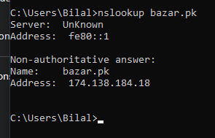

Their ip address is 174.138.184.18

1. The authorative DNS for a university in Europe is

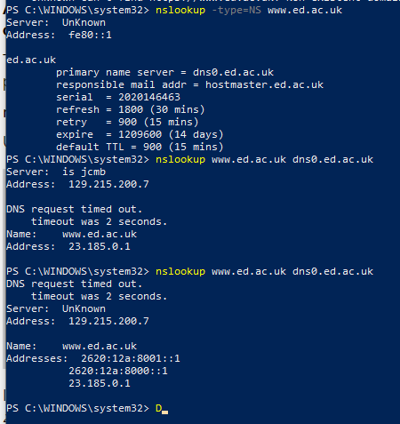



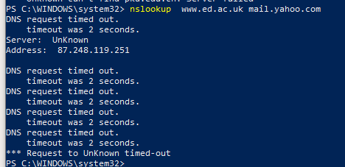

1. Messages are sent via UDP Protocol

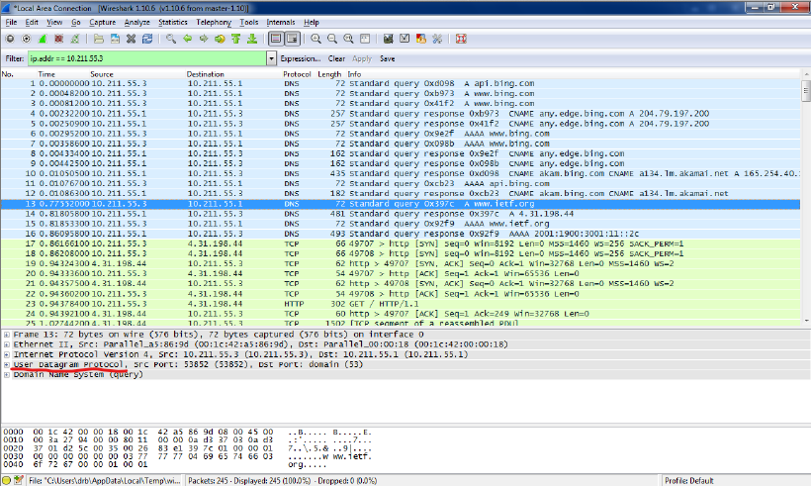

1. See screenshot. Source port: 53853. Dest port: 53.
2. The screenshot shows that the DNS message was sent to 10.211.55.1. This matches the DNS server listed by the command ipconfig /all.

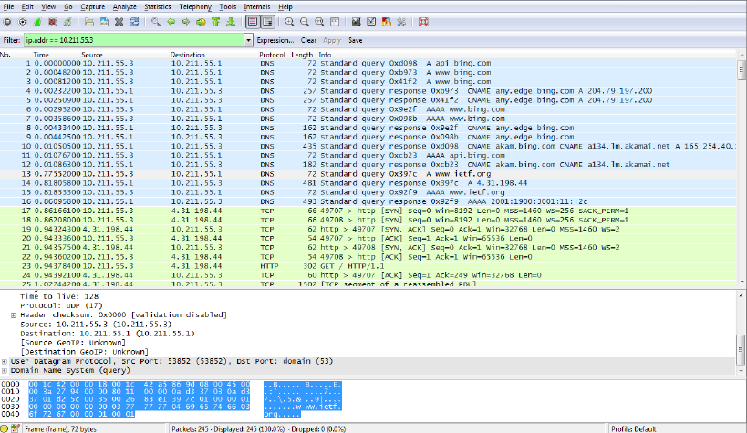

1. It is a “type A" query, which is for a standard host address resource record. No answers as shown in screenshot

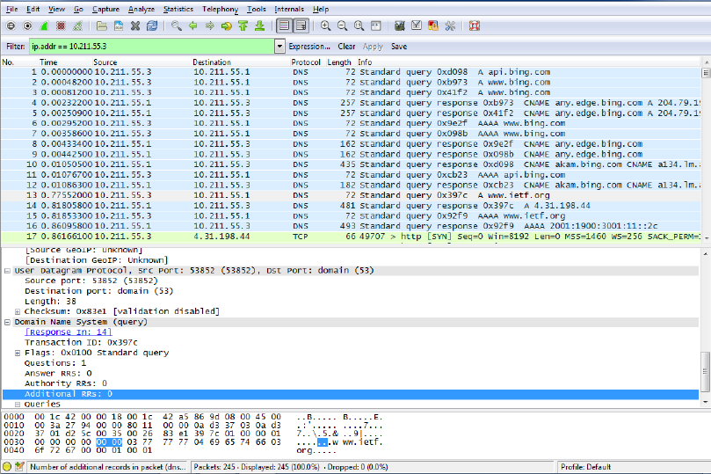

1. One answer containing the IP address of [www.ietf.org](http://www.ietf.org)

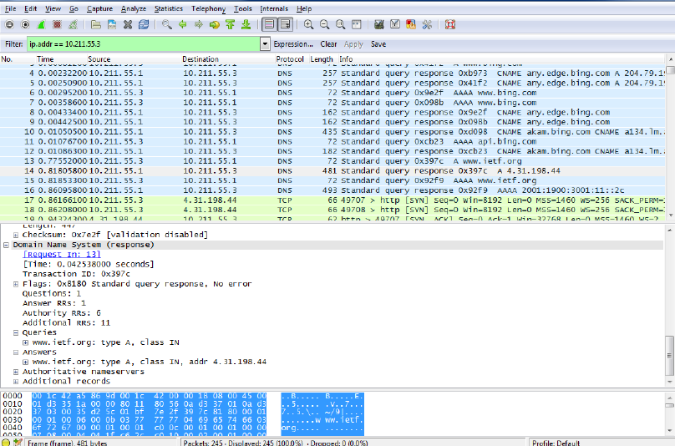

11. 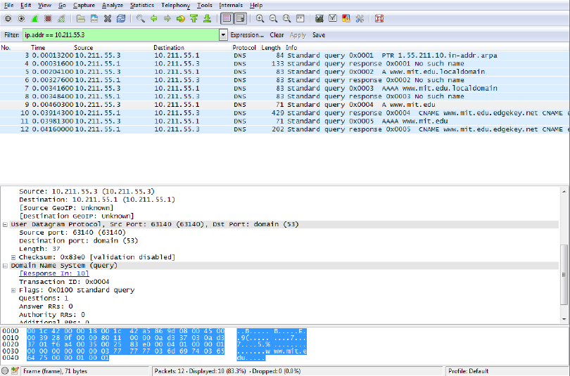

Source port: 63140. Dest port: 53

12. DNS Query message was sent to 10.211.55.1

13. Standard type A (Host address) query (see screenshot). The message

only contains a query (no answers).

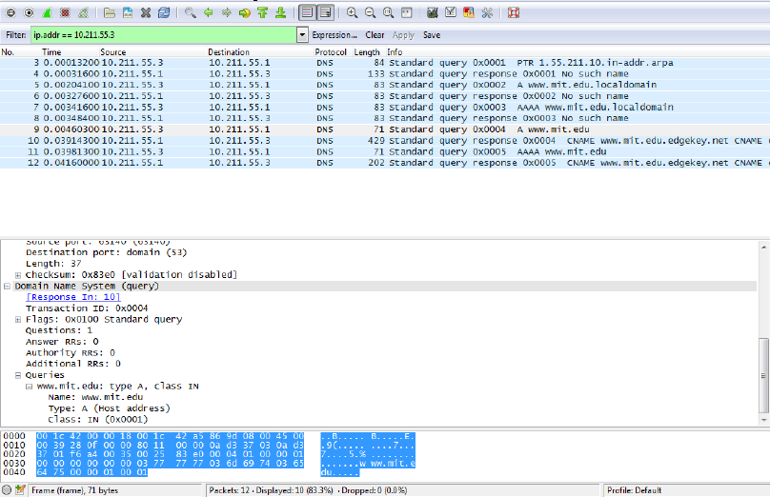

14. Three answers (resource records), two corre-

sponding to CNAMEs and one host address.

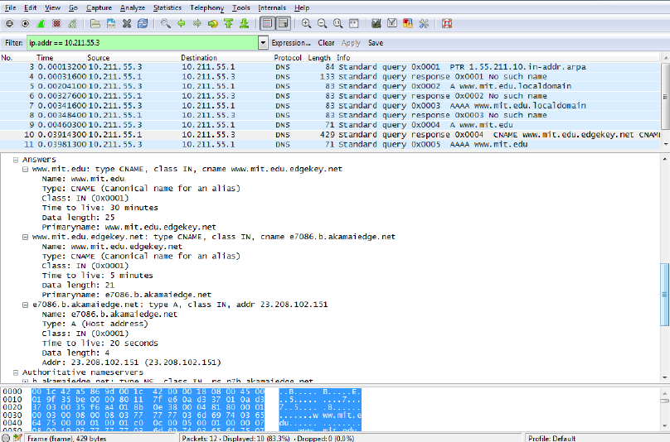

16. It was sent to 23.33.6.100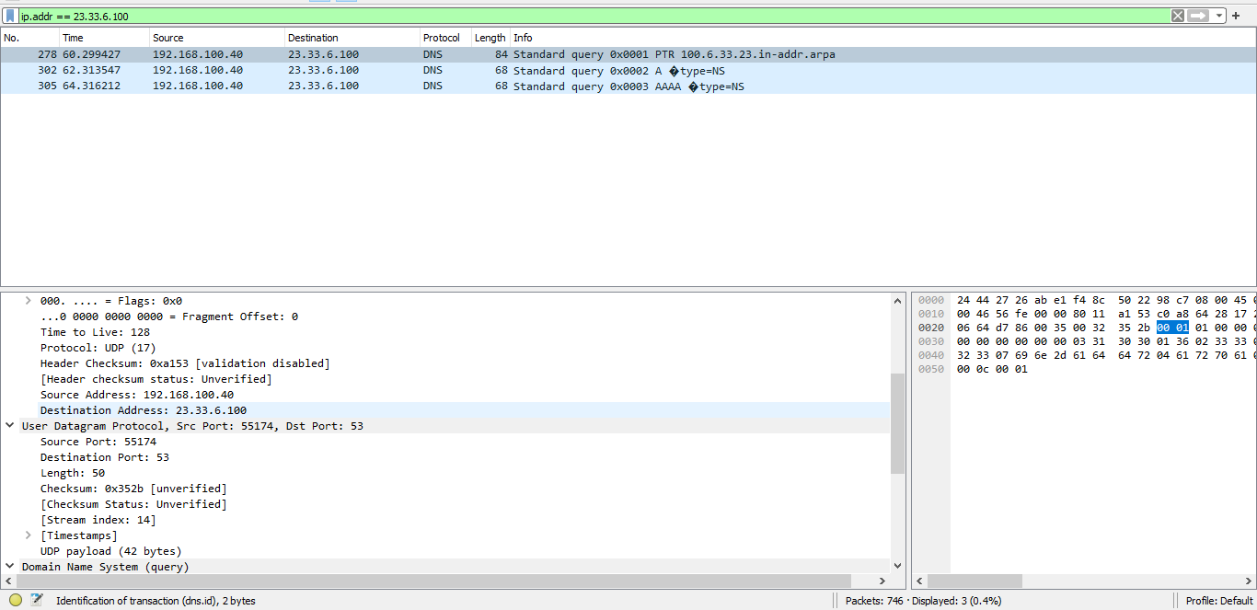

17. It is a “type A" query, which is for a standard host address resource record. No answers as shown in screenshot

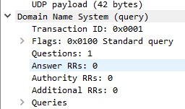

18. No the query request timed out thus no answers

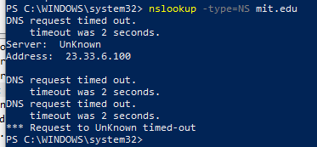

19. It’s a DNS Query

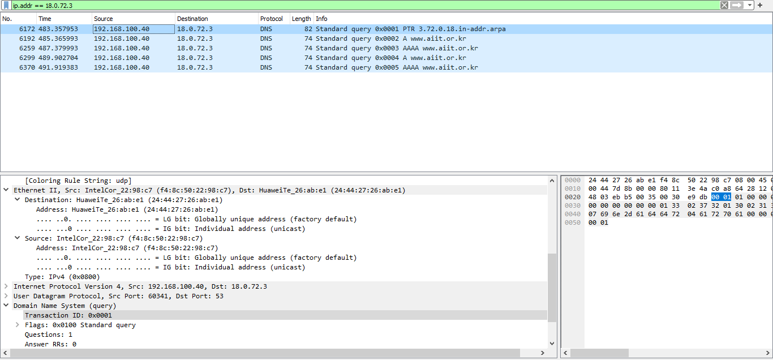

20. I was unable to get this to

work with bitsy.mit.edu so I used the Google public DNS 8.8.8.8. The query is sent to 8.8.8.8

(not the default local DNS server).

21. It is a “type A" query, which is for a standard host address resource record. No answers as shown in screenshot

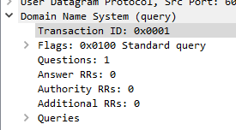

22. The request timed out thus no answers provided.

